Testing scenario using Swagger

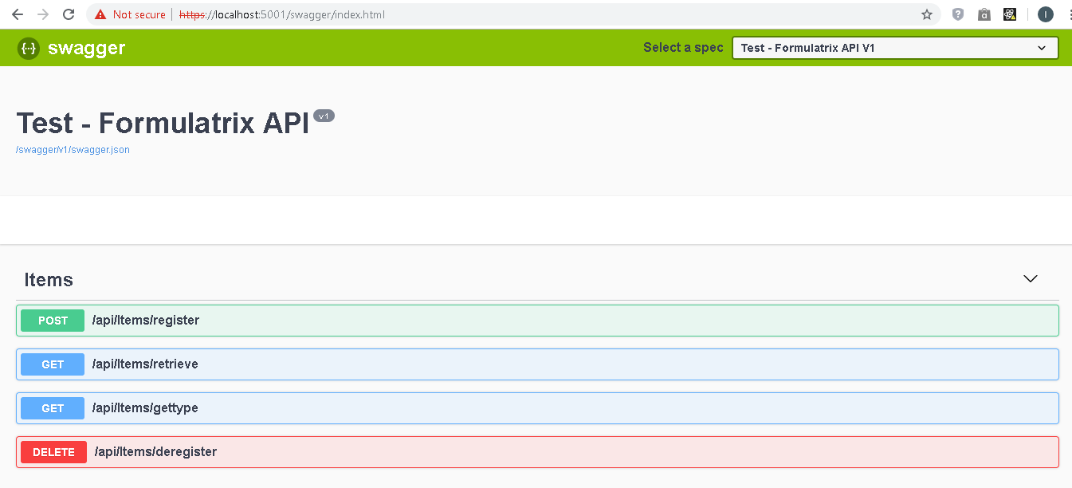

Image 1. General Function that can be used

This is API that available for use in Web API.

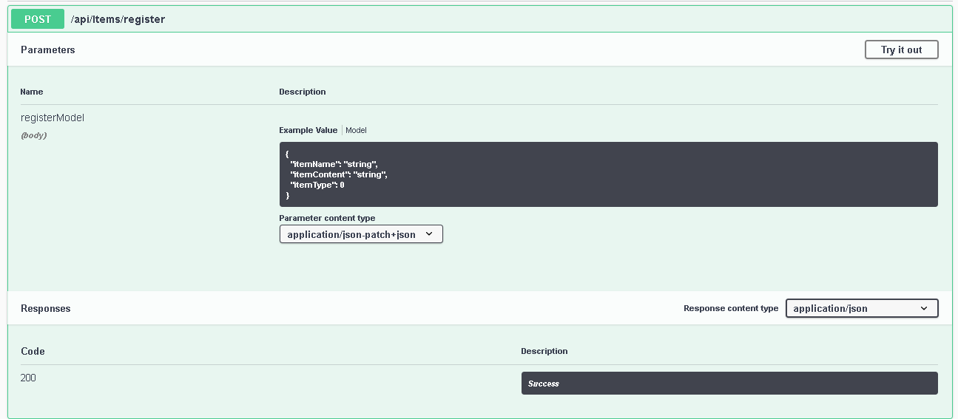

Image 2. General View Register Function

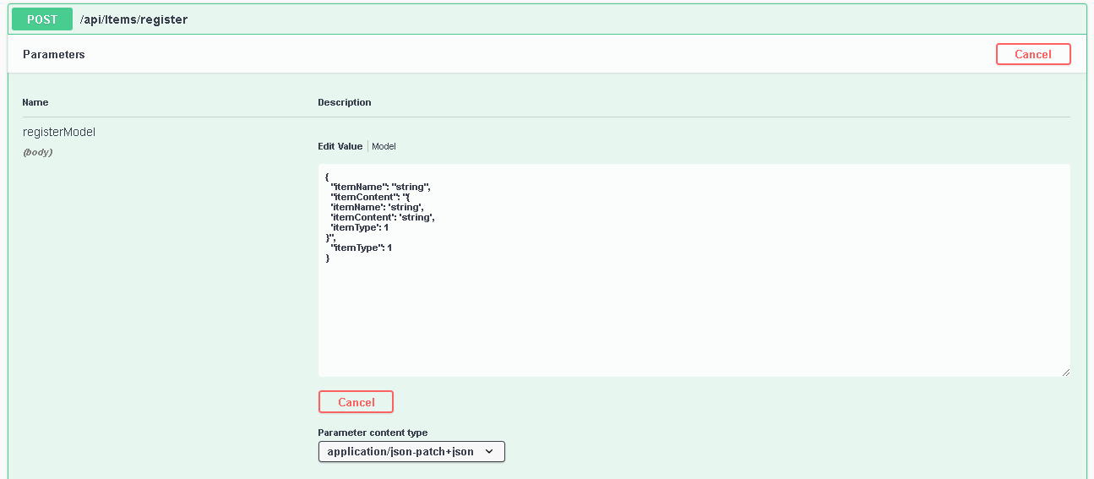

Image 3. Testing Request Register Function

In the picture above, the parameter are set with value. The field ItemType is 1 and ItemContent set with json format.

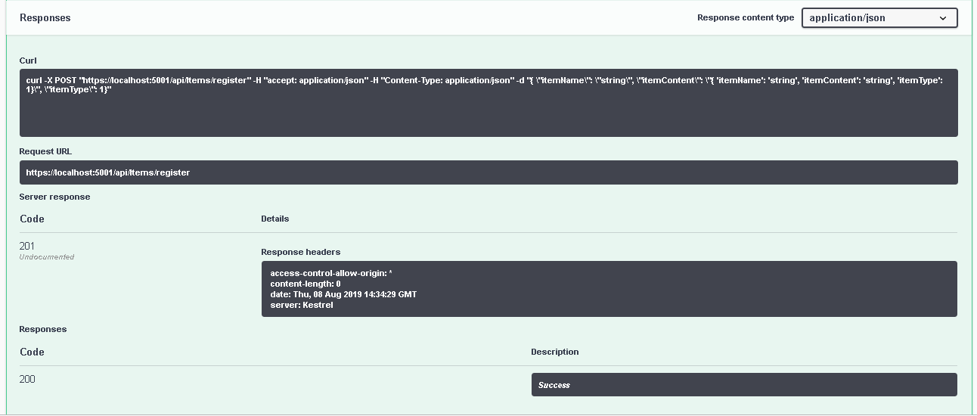

Image 4. Response from register with ItemType 1

In the picture above, Item has been save in memory, with HttpCode 201

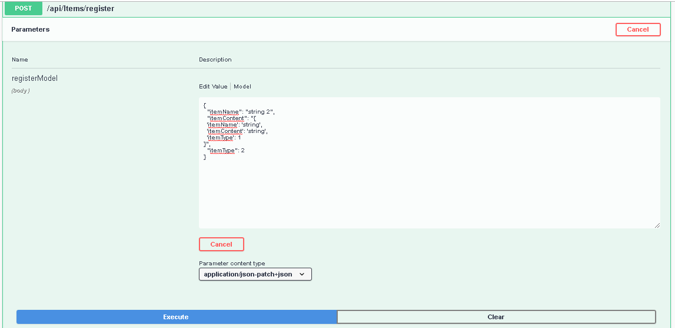

Image 5. Testing request ItemType 2 but ItemContent Json Format

In the picture above, this is false condition, the expected result, it is should be failed to store in memory.

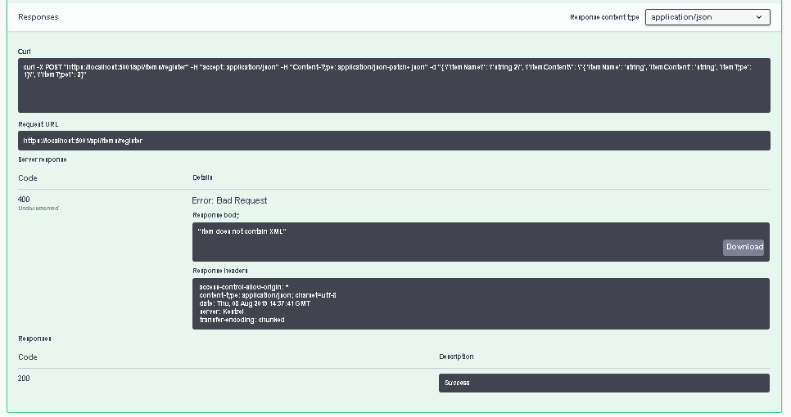

Image 6. Result false condition with different data ItemType and ItemContent

In the picture above, the data will response with status code 400 which is Bad Request, because it has create rule for ItemType 2 just only store ItemContent with XML format.

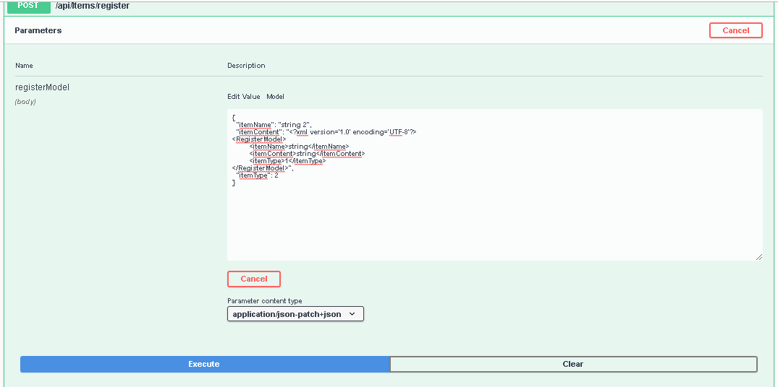

Image 7. Testing Register with XML for ItemContent

In the picture above, the expected result should be success when save data, the field itemtype set with 2 and itemcontent fill with xml data

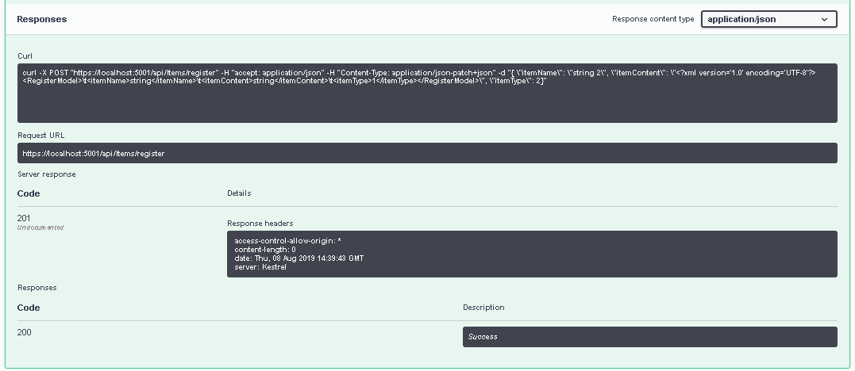

Item 8. Result of register XML data

In the picture above, response of request return Status Code 201 which is Created data done in memory

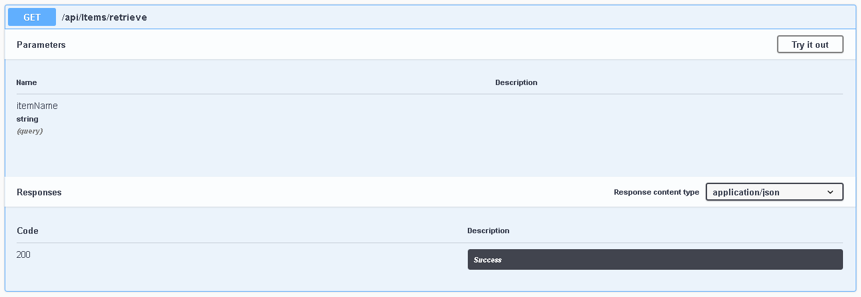

Image 9. General view of retrieve action

In the picture above, this will being scenario for retrieve Item base on itemname

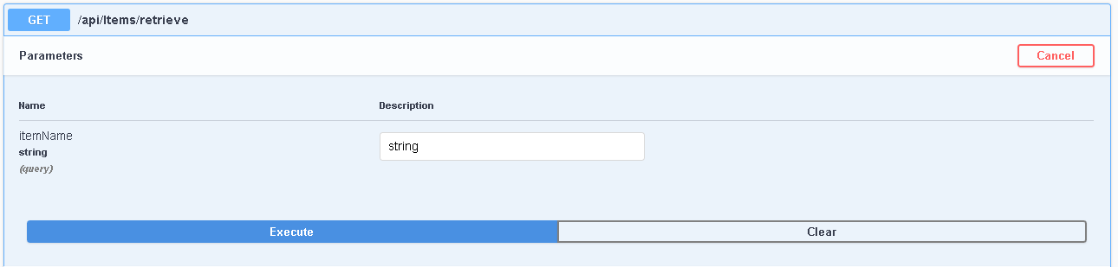

Image 10. Test retrieve function with “string” value

In the picture above, I will set itemname with “string”. This is should return Item value that already store in memory

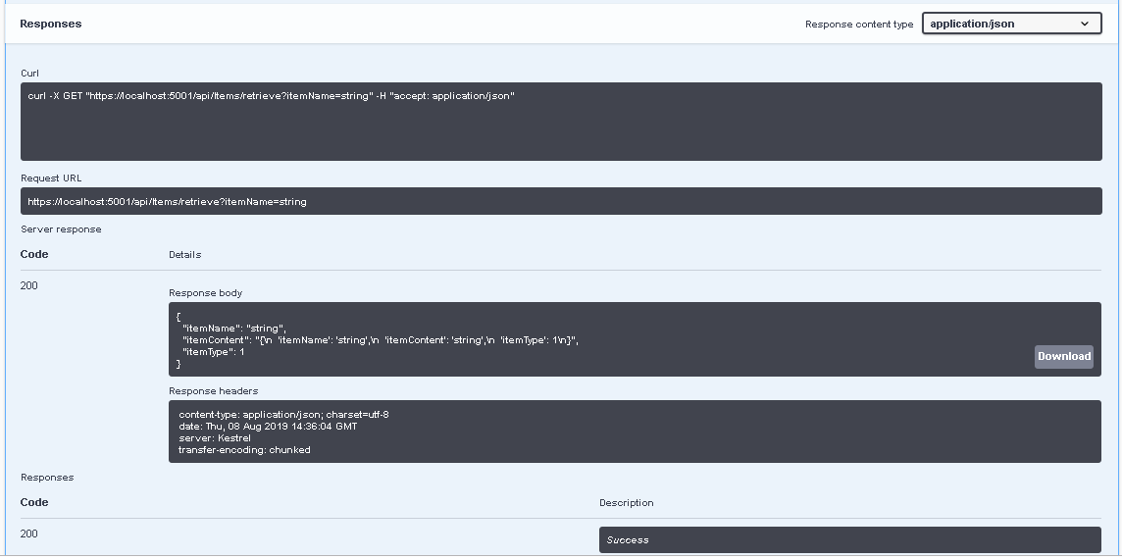

Image 11. Response of request retrieve data

In the picture above, the function successful retrieve data from memory, with status code 200, and return data in response body

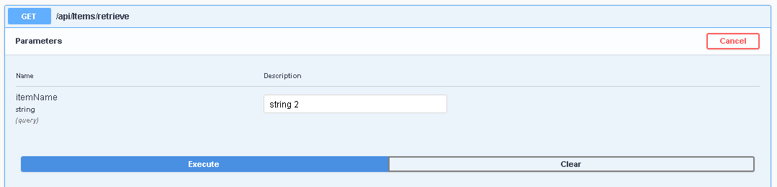

Image 12. Test retrieve function with “string 2” value

In the picture above, I will set itemname with “string 2”. This is should return Item value that already store in memory. The itemcontent should be xml format.

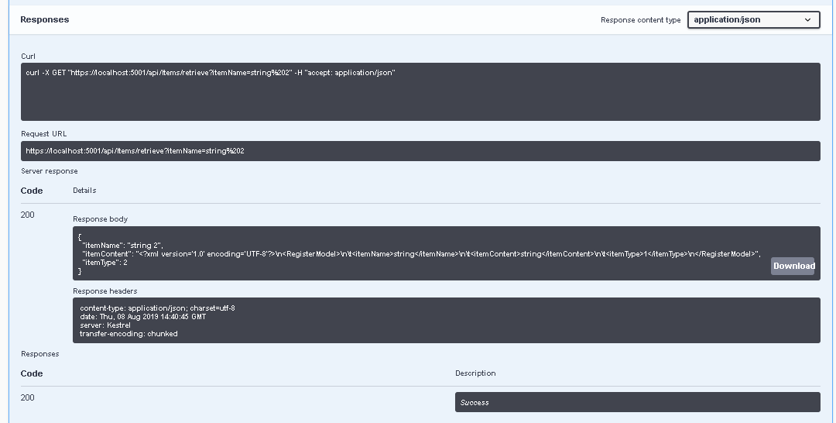

Image 13. Response of request retrieve data XML

In the picture above, the function successful retrieve data from memory, with status code 200, and return data in response body

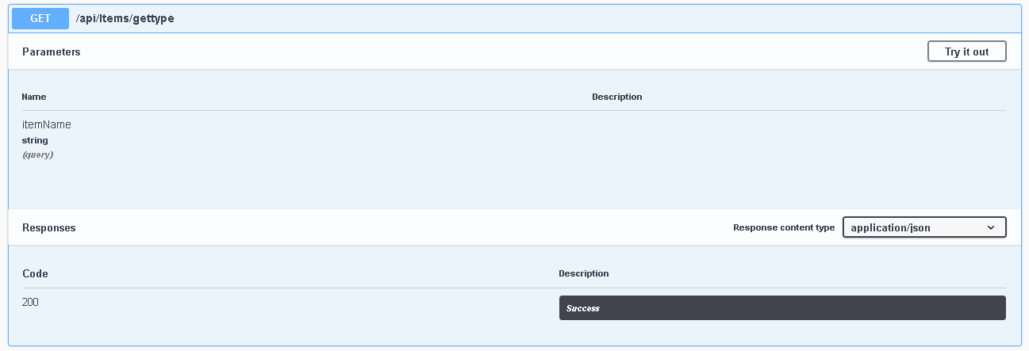

Image 14. General view of gettype action

In the picture above, this will being scenario for retrieve ItemType base on itemname

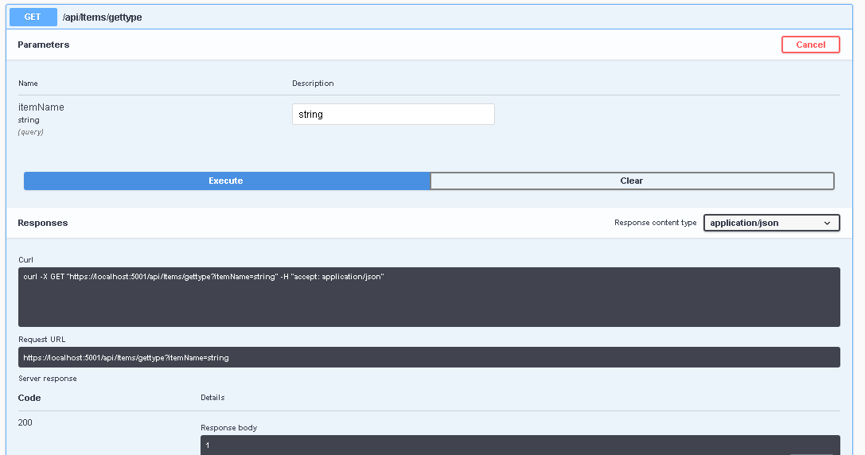

Image 15. Test retrieve gettype function with “string” value

In the picture above, I will set itemname with “string”. This is should return ItemType that already store in memory. And the result return status code 200 and response value 1

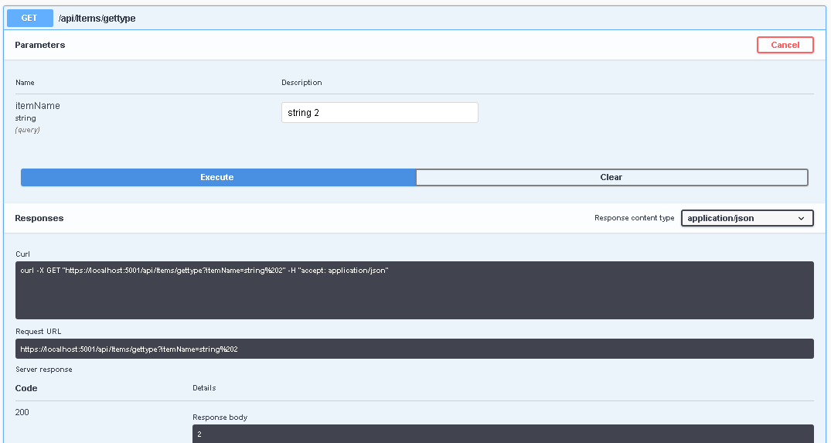

Image 16. Test retrieve gettype function with “string 2” value

In the picture above, I will set itemname with “string 2”. This is should return ItemType that already store in memory. And the result return status code 200 and response value 2

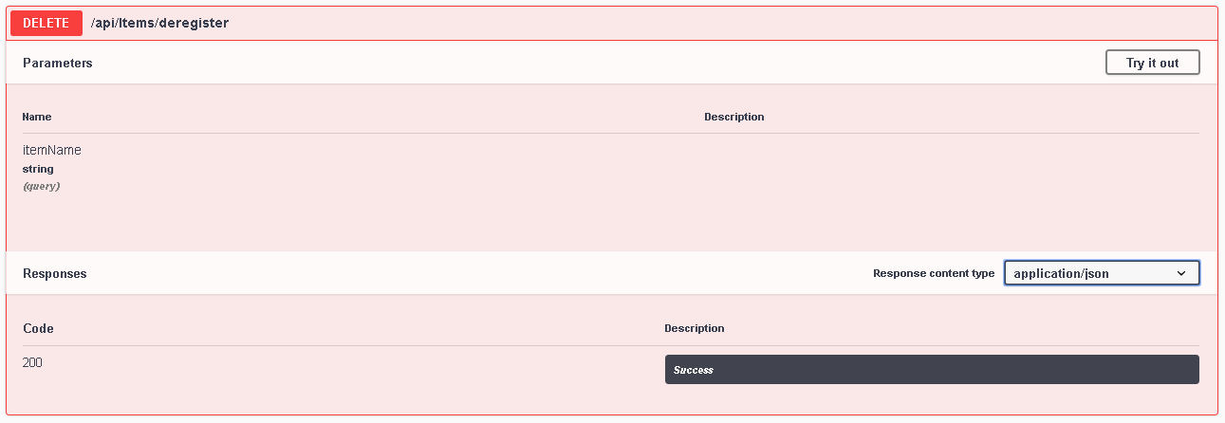

Image 17. General view deregister function

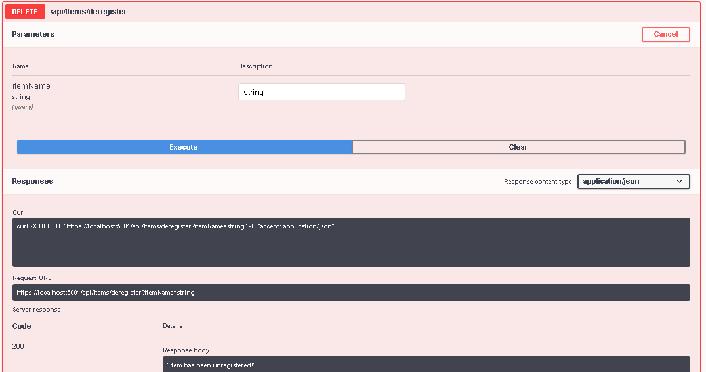

Image 17. Try to remove “string”

In the picture above, I set itemName “string” for deletion. And result of that action response Status Code 200 and success to delete.

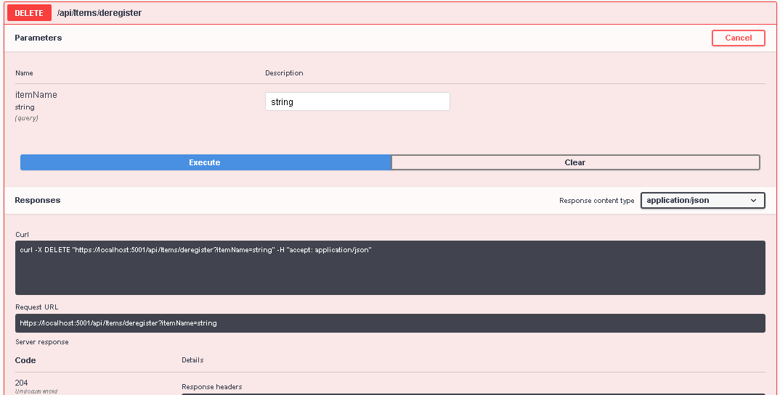

Image 18. Try to remove “string”

In the picture above, I set itemName “string” for deletion. And result of that action response Status Code 204 which no content. Because the Item already deleted.